Requirement Analysis
Data Flow Diagram (DFD)
Date | 12 July 2026
Team ID | SWTID-2026-4644
Project Name | Smart Lender
Phase | 2. Requirement Analysis

Level-0 DFD (Context Diagram) — Description
At the highest level, Smart Lender has one external entity (the Loan Applicant) and one process (the Smart Lender System). The applicant sends application details into the system and receives an eligibility decision back. This context diagram is expanded into the Level-1 DFD below, which shows the internal processes and data stores.

Level-1 DFD
The Level-1 DFD shows how applicant data moves through Smart Lender: from the web form, through encoding and scaling, into the trained classification model, and back to the applicant as a prediction. The dashed edges represent the offline model-training pipeline (notebooks) that produces the artifacts the live application depends on.
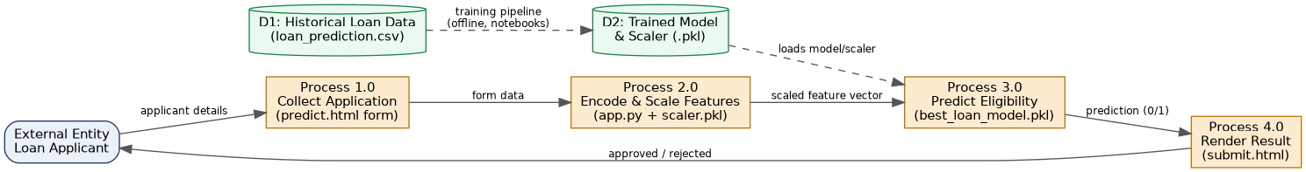
Figure 1: Level-1 Data Flow Diagram — Smart Lender.

Process Descriptions
Process | Input | Output
1.0 Collect Application | Applicant details entered in predict.html | Raw form data (11 fields)
2.0 Encode & Scale Features | Raw form data | Scaled numeric feature vector
3.0 Predict Eligibility | Scaled feature vector + loaded model | Binary prediction (0/1)
4.0 Render Result | Binary prediction + original form data | Rendered submit.html page

Data Stores
- D1: Historical Loan Data (dataset/loan_prediction.csv) — 614 records used only during the offline training pipeline, not read at request time.
- D2: Trained Model & Scaler (models/best_loan_model.pkl, models/scaler.pkl) — loaded once at Flask application startup and reused for every prediction request.

